**Control and Coordination**

For survival, an organism’s body must respond correctly to various stimuli it receives.

#### Some important terms:

* **Stimulus:** An agent or sudden change in the external or internal environment which causes a change in an organism or any of its body parts.
* **Response:** The change in organisms resulting from a stimulus.
* **Receptors:** Nerve cells which initiate waves of impulses towards the central nervous system on receiving a stimulus.
* **Effectors:** Muscles or glands which contract or secrete substances on receiving an impulse from the brain or spinal cord.

# Functions of the Nervous System

* Keeps us informed about the outside world through sensory organs.
* Controls and harmonises all voluntary muscular activities. Example- running and writing.
* Enables us to remember, think and reason.
* Regulates involuntary activities such as breathing and beating of the heart.

# Neuron

* A **neuron** is the structural and functional unit of the nervous system.

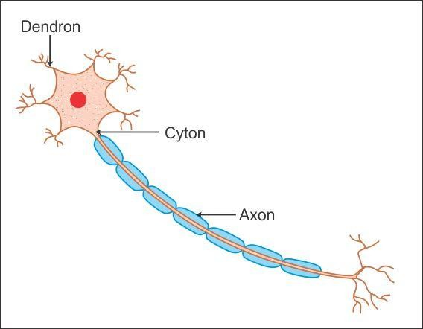

The three main parts of a neuron are:

* Cell Body- It has a well defined nucleus and granular cytoplasm.
* Dendrites- Dendrites are branched cytoplasmic projections of the cell body.
* Axon- It is a long process of the cell body. The end portions of the axons have swollen bulb-like structures which store neurotransmitters.

# Synapse

* The **synapse** is the point of contact between the terminal branches of the axons.

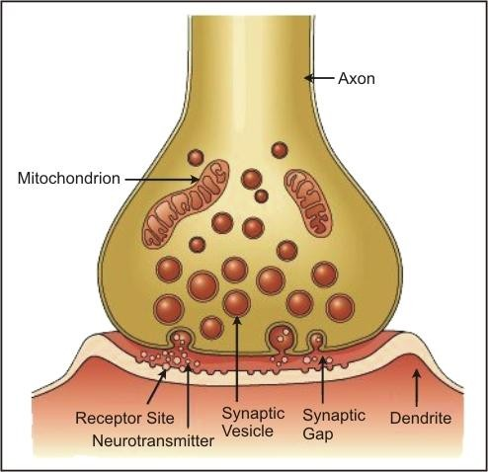

* Axon terminals of a neuron and the dendrites of another neuron are separated by a fine gap, i.e. a

#### synaptic cleft.

* The nerve impulse is sent across the synaptic cleft with the help of the neurotransmitter acetylcholine.

# Reflex Action

* Involuntary actions in response to external or internal stimuli are termed as **reflex actions**.
* The peripheral nervous system and spinal cord are involved in controlling reflex actions.
* The path travelled by the impulse during a reflex action is called a reflex arc.
* A reflex arc can be represented as follows:

#### Stimulus → Receptor in the sense organ → Afferent (sensory) nerve fibre → CNS (spinal cord)

→ **Efferent (motor) nerve fibre** → **Muscle/Gland** → **Response**

**Examples of Reflex Arc**

* When you touch a hot object, you withdraw your hand from it immediately.
* Shivering when it is too cold or sweating when it is too hot.
* Dilation of the pupils of the eye to look in the dark and *vice versa*.
* When you smell your favourite dish, your mouth waters.

# Divisions of the Nervous System

**Peripheral Nervous System (PNS)**

**Central Nervous System (CNS)**

**Nervous System**

### The Central Nervous System

The central nervous system includes the brain and the spinal cord.

### The Brain

* + The human brain is the largest among all animals.

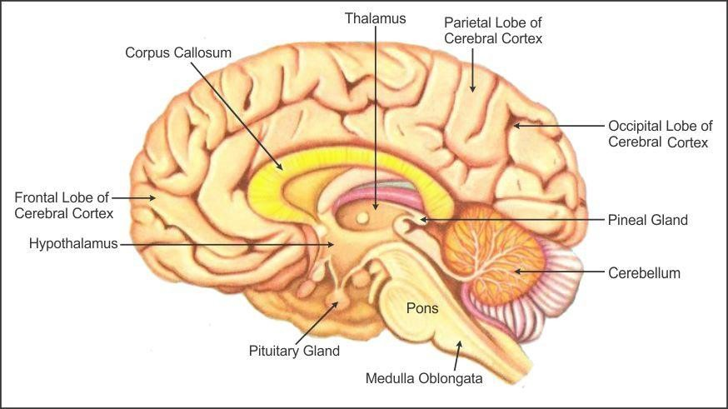

* + It is well protected by the cranium or the skull.
  + Three membranous coverings called meninges cover the brain.
  + Inflammation of the meninges is called meningitis.
  + The space between the covering membranes, central spaces of the brain and the central canal of the spinal cord is filled with **cerebrospinal fluid**.
  + Three primary regions of the brain are forebrain, midbrain, and hindbrain.

|  |  |
| --- | --- |
|  |  |
|  | Cerebellum |
|  |
|  | Pons |
|  |
| Medulla Oblongata |
|  |

### Parts of the Brain

Brain

Forebrain

Midbrain

Hindbrain

Cerebrum

Diencephalon

Thalamus

Hypothalamus

|  |  |
| --- | --- |
| **1. Cerebrum** | * It is divided into two cerebral hemispheres connected to each other by the **corpus callosum**. * The walls have an outer cortex and inner medulla. * The cortex contains cell bodies of the neuron and is greyish in colour; hence, it is called **grey matter**. * The medulla consists of axons of the nerve fibres and is called   **white matter.** |
| **2. Cerebellum** | * It is located at the base of the cerebrum. * It has numerous furrows. |
| **3. Medulla Oblongata** | * It is located at the base of the skull. * It is roughly triangular. * It continues behind the brain as the spinal cord. * Injury to the medulla oblongata results in death. |

1. **The Spinal Cord**
   * Extends from the medulla oblongata down to almost the whole length of the backbone and ends at the second lumbar vertebra.
   * The grey matter is on the inner side and white matter is on the outer side of the spinal cord.
   * The spinal cord is responsible for reflexes below the neck.
   * It conducts sensory impulses from the skin and muscles to the brain.
   * It conducts motor responses from the brain to muscles of the trunk and limbs.

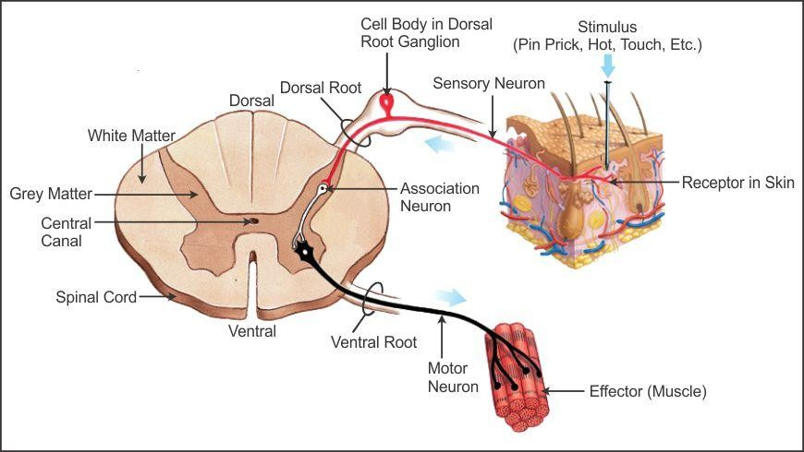

### Peripheral Nervous System

* The Peripheral Nervous System consists of nerves which carry impulses to and from the central nervous system.

Peripheral Nervous System

Somatic Nervous System (Cranial and Spinal Nerves)

Autonomic Nervous System

Sympathetic System

Parasympatheti c Nervous System

* The Somatic Nervous System is made up of 12 pairs of cranial nerves and 31 pairs of spinal nerves.
* Cranial nerves emerge from the brain and spinal nerves originate from the dorsal and ventral roots of the spinal cord.

# Coordination in Plants

### Nastic Movements

* The movement of a plant in response to an external stimulus, in which the direction of response is not determined by the direction of stimulus, is called **nastic movement**.
* Nastic movements are shown by flat parts of the plants such as leaves and petals.
* Example-

Daisy flowers close at dusk and open at daybreak; this may be referred to as sleep movements.

This response however should not be confused with thigmotropism as the folding of leaves always occurs in the same direction irrespective of the direction of the stimulus.

* Two types of nastic movements are:

1. **Photonasty** is a nastic movement to the light and dark phases of the day.

Example- Flowers of primrose blossom during the evening but close during the day.

1. **Nyctinasty** is the movement in response to dark. Certain parts of a plant such as the leaves and flowers take up a different posture at night than that in the day.

Example- Leaves of the rain tree fold by nightfall.

**Movement Due to Growth**

The movement of plant organs towards or away from a stimulus is known as **tropism**.

Since the tropic movements are slow, the stimulus needs to be continued for a longer time for the effects to be noticed.

The different types of tropic movements in plants are:

|  |  |
| --- | --- |
| **1. Phototropism** | * The movement of plant parts towards or away from light is termed as phototropism.  * Because shoots of most plants grow towards the source of light, it is termed as positive phototropism. * Roots grow away from light and hence are negatively phototropic. |
| **2. Geotropism** | * The movement of plant organs in response to gravity is termed as geotropism.      * Roots are positively geotropic because they grow in the direction of gravity. * The shoot grows upwards, i.e. against gravity, and hence is negatively geotropic. |

|  |  |
| --- | --- |
| **3. Thigmotropism** | * The movement of plant organs in response to stimuli caused by physical contact with solid objects is termed thigmotropism. * Weak-stemmed plants use twining stems and tendrils to climb on other plants/objects which provide them support. Hence, twining stems and tendrils   are positively thigmotropic. |
| **4. Hydrotropism** | * The movement of plant organs in response to water is termed hydrotropism.  * Roots grow towards the source of moisture and hence are positively hydrotropic. |
| **5. Chemotropism** | * The movement of plant organs in response to a chemical stimulus is called chemotropism.  * When plant organs grow away from the chemical response it is called negative chemotropism. * When plant parts grow towards the chemical response it is called positive   chemotropism. For example, pollen tubes grow towards the sugary substance secreted by the stigma of the flower. |

# Plant Hormones (Phytohormones)

Plant hormones control some aspects of the growth of plants such as cell division, cell enlargement and cell differentiation.

|  |  |
| --- | --- |
| **Phytohormones** | **Description** |
| 1. Auxins | * Promote growth of plants. * They are secreted by the cells present in the tip of stems and roots. * Synthetic auxins are used in horticulture. |
| 2. Gibberellins | * Promote cell differentiation in the presence of auxins. * They break seed dormancy. * Stimulate elongation of shoots. |
| 3. Cytokinins | * Promote cell division in plants. * Delay ageing of leaves. * Promote opening of stomata. * Promote fruit growth. |
| 4. Abscisic Acid | * Acts as a growth inhibitor. * It promotes dormancy in seeds and buds. * Promotes closing of stomata. * Promotes wilting and falling of leaves. * Detachment of flowers and fruits from the plants is due to abscisic acid. |

# Hormones in Animals

|  |  |  |
| --- | --- | --- |
| **Hormones** | **Functions** | **Disorders** |
| 1. Adrenaline  Produced by the adrenal glands. | * Adrenaline prepares the body for the fight and flight   mechanism. |  |
| 2. Thyroxine  Secreted by the thyroid gland. | * Regulates carbohydrate, protein and fat metabolism. * It increases the basal metabolic rate (BMR). * It regulates body growth such as ossification of bones and mental   development. | * Simple goitre * Ophthalmic Goitre * Cretinism |
| 3. Growth Hormone Secreted by the anterior lobe of the pituitary gland. | * It is essential for normal growth. | * Dwarfism * Gigantism |

|  |  |  |
| --- | --- | --- |
| 4. Insulin  Secreted by pancreas | * Regulates the blood glucose (sugar) level. | * Diabetes Mellitus High concentration of sugar in blood   (hyperglycemia). |
| 5. Testosterone  Secreted by the testes in males. | * Controls the development of sex organs in males. * Controls the development   of secondary sexual characters during puberty. |  |
| 6. Oestrogen  Secreted by the ovaries in females. | * Controls the development of female sex organs. * Controls the development of secondary sexual characters during puberty   in females. |  |

## Feedback Mechanism

* The body has mechanisms to maintain its normal state.
* Whenever there is a change in the normal state, messages are sent to increase secretions if there is a fall below the normal levels or to decrease secretions if there is a rise above the normal levels to restore the normal body state. Such a mechanism is called **Negative Feedback Mechanism**.
* Example- Blood sugar level

The increase in blood sugar level stimulates the secretion of insulin so that the sugar level is maintained. If there is a fall in the blood sugar level below normal, it stimulates the secretion of glucagon. Glucagon stimulates the breakdown of glycogen to glucose, and thus the normal sugar level is maintained.